**Heart Failure Prediction**

**Abstract:**

Cardiovascular diseases (CVDs) are the number 1 cause of death globally, taking an estimated 17.9 million lives each year, which accounts for 31% of all deaths worldwide. Heart failure is a common event caused by CVDs, our aim is to build a machine learning model for early detection.

**Data Set:**

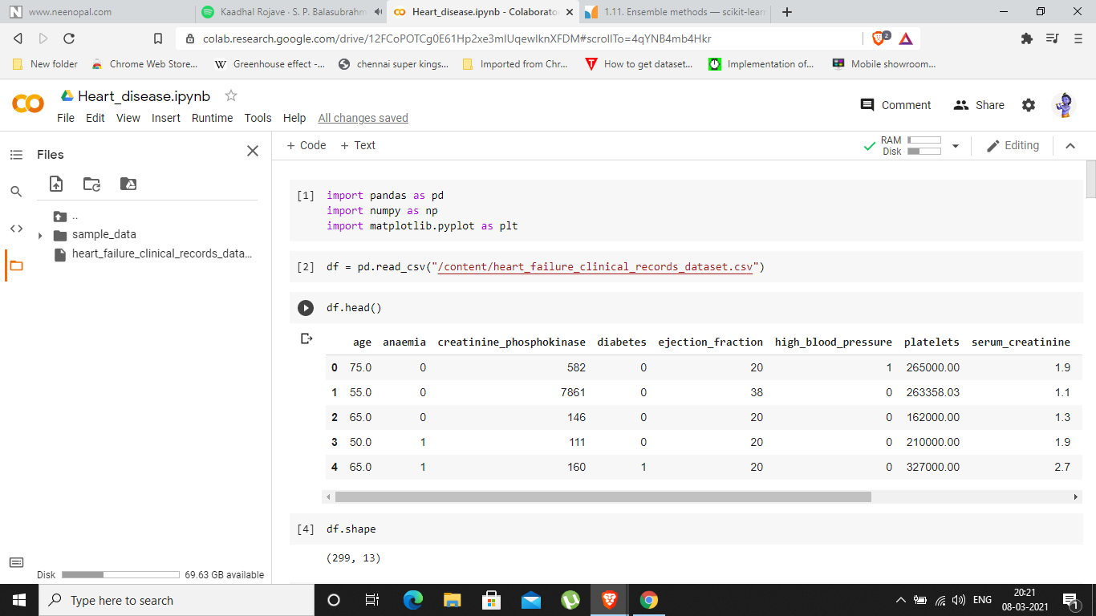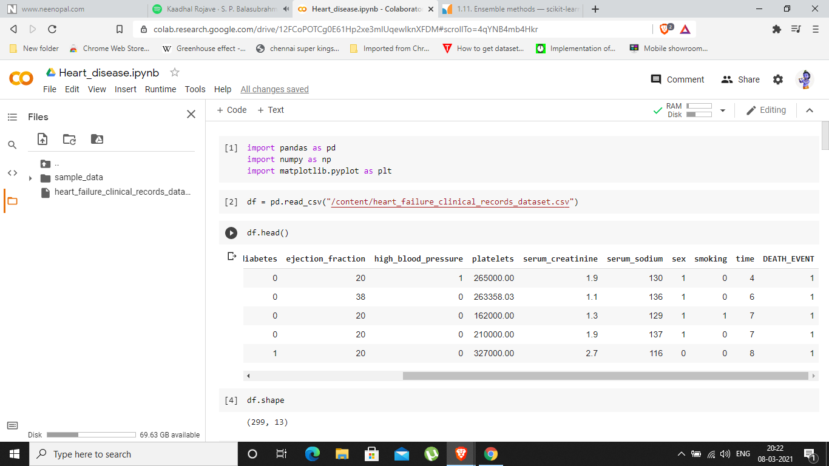

The data set contains 12 independent and a dependent variable (Death_Event)

**Model:**

**(299, 13)**

The model contains 299 records and 13 features.

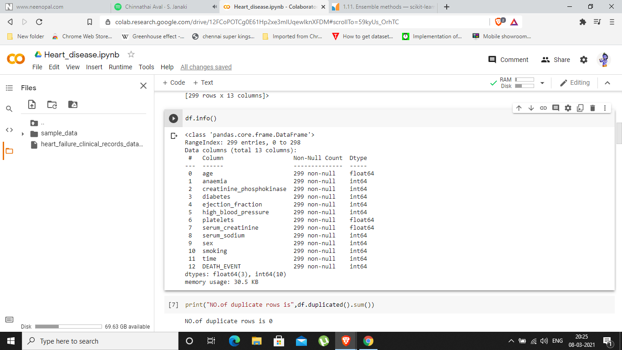

The data set contains no null values and all features are numerical.

**Data Visualization:**

**Bar Graph:**

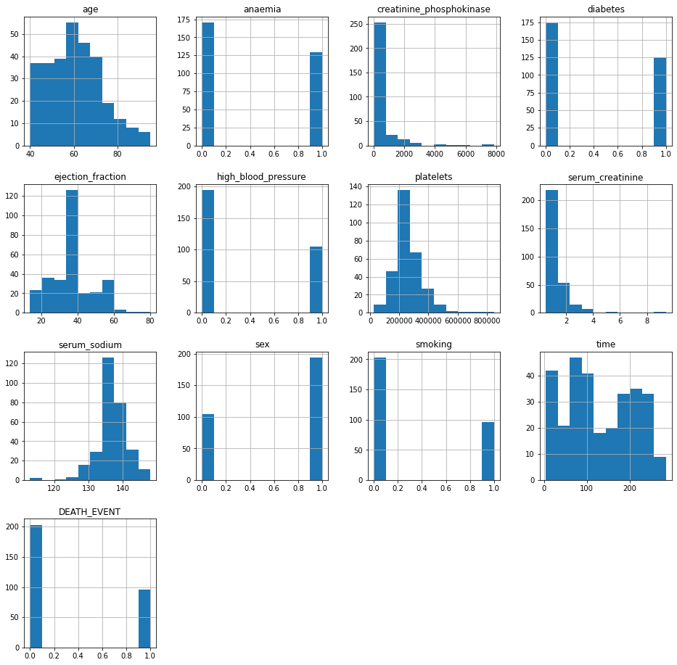

**Pie Chart:**

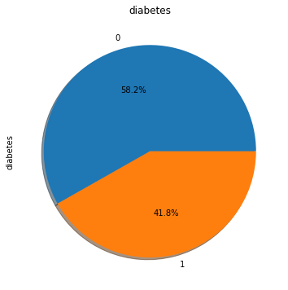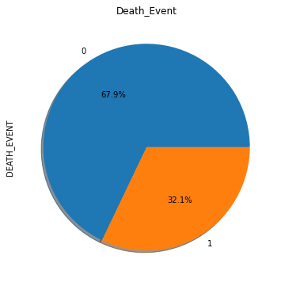

**Correlation Heatmap:**

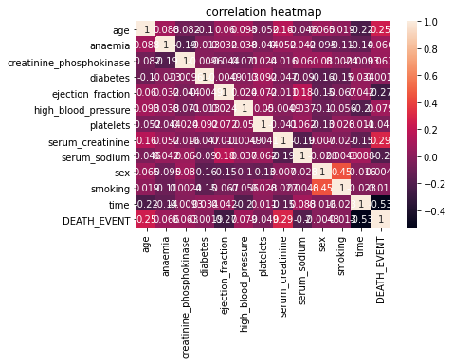

**Interpretation:**

The above Bar graph shows the distributions of each feature, and the pie chart is to visualize the Death_Event and diabetes.

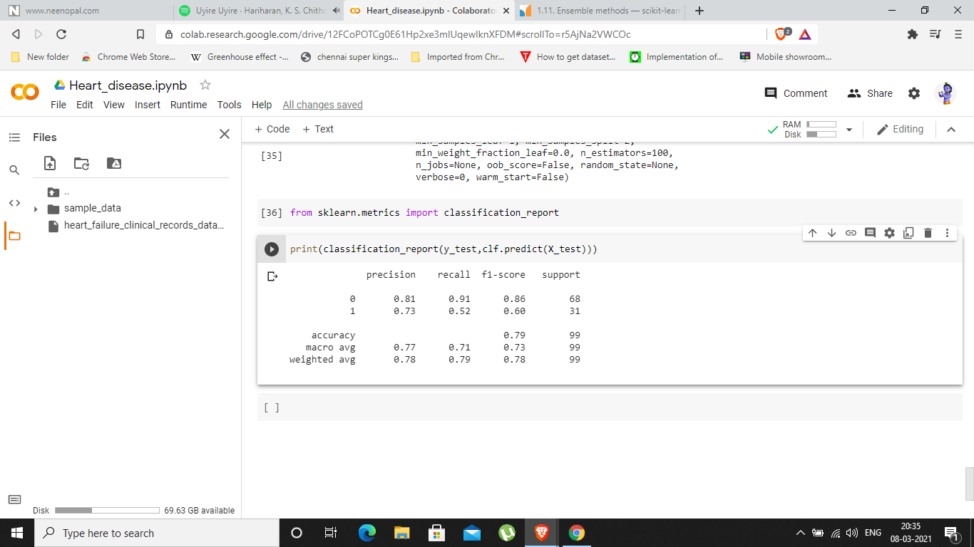

**Result:**

The precision of the model is 0.81 and 0.73 means the model predicts 81/100 persons correctly if they actually don’t have the disease and 73/100 persons correctly if they actually have the disease.